PRESIDENT – Nancy Ridout

The past year has seen growth in our numbers, progress toward achieving the objectives of the USMS Strategic Plan, and a growing awareness of the complexities of running our organization. We have also experienced growing pains and their effects on our volunteers as well as on the perception of the organization by those not active in national affairs.

I left the 2000 convention buoyed by the results of the convention survey which showed an overwhelming satisfaction and enthusiasm for USMS. Following the convention, dissatisfaction was expressed by one of our delegates in regards to some actions taken by the House of Delegates. This delegate created an alternative forum for discussing USMS issues that seems to have produced a great deal of tension. To the degree that the issues discussed within this forum are legitimate and germane to our plan and organization’s management, they will be discussed at the convention in their appropriate place. We have a lot to cover and I do not intend to allow the discussions to degenerate into politics or personalities.

USMS is more than a non-profit corporation. It is a family, an extended and growing family, which has evolved and developed into a large and successful organization through the dedication, service, vision, and leadership of its volunteers. Flexibility, trust, and mutual respect have always been a part of the way we conduct our business.

This will be the end of one era and the beginning of another for USMS and for me. The delegates to this convention will elect new officers to carry on the long tradition of strong USMS leadership. Our organization has an abundance of qualified and capable leaders and you can be sure that USMS will be in good hands during the next term of our new officers.

The current Executive Committee, along with the Board of Directors, has worked consistently and diligently to be good stewards of the strong organization we inherited and to implement new ideas to make it even better. Your Executive Committee and Board of Directors of the past four years have been proactive and constantly looking for ways to offer you an even better program. Some of these accomplishments include:

- Bringing our national registration in-house and hiring the necessary staff to handle this task.
- Designing and implementing a five-year Strategic Plan for USMS.
- Hiring and contracting with a Controller for consistent and professional services.
- Hiring and contracting with a person to fill the needs for Sponsor Liaison/Public Relations services.
- Undertaking a partnership with the National Stroke Association (Strokes for Stroke) to raise funds and increase the awareness of the signs and symptoms of stroke
- Conducting a Needs Assessment Survey (2001) of our members, specifically designed to ascertain the wants and needs of our non-competitive members. The results of this survey will be shared at this convention.
- Developing and instituting a premier training camp for Masters swimmers, in partnership with USA Swimming, at the Olympic Training Center, in Colorado Springs. Four have been held to date and a fifth is planned for February, 2002.
- Negotiating a new contract with SWIM Magazine, which will continue to bring our members a high quality official publication wholly dedicated and focused on the interests and needs of Masters swimmers.
- Contracting for professional services of a USMS Webmaster.
- Contracting for professional services of a USMS SWIM Magazine Editor.
- Increasing closer relationships with like-minded organizations such as USA Swimming, the National Senior Games, National Parks and Recreation Administrators, YMCAs, and the US Olympic Committee.
- Designing and implementing evaluation criteria and procedures of our employees and reviews of our contractors.
- Instituting mid-year Executive Committee meetings to better assess, take action, and plan for the growing needs of USMS.
- Developing a closer relationship with our sponsors and seeking to create new relationships designed to give our members new opportunities and benefits.
- Developing and obtaining licensing agreements for the use of the USMS logo.

PRESIDENT Continued

On behalf of Vice President Jack Geoghegan, Secretary Betsy Durrant, Treasurer Jeanne Ensign, Past President Mel Goldstein, Zone Chair Lynn Hazlewood, and Legal Counsel Jeanne Crouse, I thank you for your support, kind notes, suggestions, problems to solve, and most of all, the opportunity to serve the organization we value so highly. For me, it has been an opportunity to emphasize a management style that incorporates a myriad of leadership skills, talents, and teamwork, an opportunity to represent USMS and exchange ideas with international Masters leaders and swimmers, an opportunity for personal growth and realization of previously unknown aptitudes, and not least of all, the chance to get to know so any of you, the ”movers and shakers” of United States Masters Swimming.

After the convention, though I will remain a part of the USMS Executive Committee for the next four years, I plan to use the 20-30 hours a week I now spend on USMS business to give more time to my paying job, to train for a successful new year in a new age group, and to spend evenings with my husband instead of my computer and phone. I can’t begin to tell you what a fantastic and exciting experience it has been to serve as President of this exceptional organization. I thank you for the opportunity.

Yours in friendship and with thanks,

Nancy Ridout, President
United States Masters Swimming

BOARD OF DIRECTORS MEETING AGENDA

Wednesday, September 12

4:15-5:45 pm

- Welcome, Introductions, Updates
- Report of the Executive Committee
- Concerns of the Board of Directors
- Legislation Proposals of Interest or Concern to the Board of Directors
- Election Schedule and Procedures
- Other

VICE PRESIDENT – Jack Geoghegan

As your Vice President and candidate for retirement from the USMS administrations, I wish to express in this forum my deep appreciation for the opportunity of working for and with all of you over the past 20- yes it is that long-years. Others of the Executive Committee will detail in fulsome manner the myriad things with which we have been involved, but, here, I would like to tell you what a pleasure it has been to experience the dedication and enthusiasm of so many individuals all over our country during those 20 years. What makes our sport unique is the self governing, something I hope we will never lose. Personally, I am gratified at the expansion of recognition of our non competitive members and the effort to bring value to their membership. Going forward the future of our sport lies in younger hands and yet some of the wisest words I have read in the many e-mails and discussion forums have come from the earliest of our leaders, June Krauser and Ted Haartz. I believe our Past Presidents- all of whom continue to serve our organization- are an unmatchable resource. Change is inevitable and, for the most part, a good thing, but we must assure we do not" throw the baby out with the bathwater." Also, when we communicate , we must show respect for each other and differing opinions, even though we disagree with them. We are all involved in Masters governance for the betterment of our sport, and civility is never out of fashion and must always be used. Recently, it seems, some of us have forgotten the good lessons our mothers taught us. I apologize for this polemic, but, personally, I felt the need to say it and having had my day; will wish you ALL: good health, good friends, good times and most of all, great FUN in Masters swimming. I'll see you in the pool!

SECRETARY – Betsy Durrant

I want to thank everyone for giving me the opportunity to serve as Secretary and for helping me out when I needed it. It has been a lot of work, but I have learned a lot and have enjoyed working with and getting to know so many different people. I especially want to thank Nancy Ridout and the rest of the Executive Committee. They are truly dedicated to the spirit of Masters swimming. And finally, without the help of Tracy Grilli, any USMS job would be harder and less enjoyable.

Something new this year ... the minutes of the Executive Committee meetings and conference calls are posted on the website. This was in response to requests for copies and seemed the best way to keep those who are interested informed about the issues.

In response to suggestions at the Sunday session after last year’s convention, I have spent time this spring and summer in revising the Committee Report form to make it easier to find each report and to read it. I have also revised the convention evaluation (or exit survey), incorporating suggestions that were on last year’s evaluation forms.

In gathering delegate names from LMSCs, I have compiled a list of new delegates to this year’s convention. I passed the list on to Lynn Hazlewood and the Zone Committee who are setting up a mentor program for new delegates.

I look forward to seeing you at the convention.

TREASURER – Jeanne Ensign

As always, issuing reimbursement checks to you for expenses incurred on behalf of USMS has continued to be the most visible part of my work. I write checks as authorized by the Controller and in addition to reimbursements, I pay all other ongoing expenses as necessary. I monitor registration and other income received by the national office. I continue to invest cash reserves in accordance with the Financial Operating Guidelines. I oversee employee wages and contractor payments which are prepared by an outside agency. Your donations to ISHOF and the endowment fund are forwarded. During the year I responded to a number of questions from teams, Clubs and LMSCs regarding IRS exempt status and filing requirements. I reviewed pending contracts for financial considerations. I reviewed financial records prepared by the Controller documenting income and disbursements.

It has been a busy and interesting year as part of the Executive Committee as well. In addition to our monthly conference calls, we had a productive and informative meeting in The Woodlands in January.

Following consideration of USMS’ financial position and activities, a recommendation from our internal auditor and from outside legal counsel, the Executive Committee recommended an audit of the 2000 financial statements by an outside CPA firm. The audit is in process, and the report, which is not yet available, will be presented at convention. The audit and accompanying management letter will help us proceed professionally and competently into the future.

On a personal note, this is my fourth report to you as treasurer - the end of my second term. I’m honored to have been elected an officer of this special organization and to have served USMS in this capacity. My respect is undiminished for the volunteers that do the work on every level and in all areas to keep our organization thriving. I am grateful for the commitment and dedication of my fellow Executive Committee members and appreciate the teamwork attitude that makes our work easier. I lost count of the times I missed my 5 am workout because I stayed up too late doing something for USMS (but I can swim tomorrow because I know my coach always gets up).

ZONE CHAIRMAN – Lynn Hazlewood

My first year on the Executive Committee has largely been devoted to "catching up" on three years of activities. It was very interesting to learn about the inner workings of the committee, but, I have to admit, sometimes I have felt like I was coming in at the end of a 3-year conversation. I'd like to thank the other members of the committee for their patience and willingness to revisit topics they had already left behind them. I have found the current Executive Committee a truly collaborative effort, with all members having the opportunity (and the obligation) to participate in the decision-making process.
Aside from doing my Executive Committee work and tending to the operations of the Zone Committee, my major project this year has been to run the national election where we will be electing a new President, Vice President, Secretary, and Treasurer. The candidates come from all over the country and include established leaders who have already served on the Executive Committee as well as those coming up from leadership positions on national committees and zones. The quality of candidates across the board is very high and we can truly say that this is an election that USMS "can't lose." The candidate pictures, questionnaires, and resumes are in this packet beginning on page 53.
A by-poduct of running the election was my decision to push forward the idea of consolidating the Election Operating Guidelines. The history of our modern guidelines is contained in 9 different documents, beginning with the guidelines passed in 1991 in the House of Delegates. The original document was amended in 1992 and 1996. Since that time, Zone Committees have recorded changes directly in meeting minutes without bringing forward the original guidelines with amendments. The historical record can be viewed on the USMS web site at www.usms.org/admin/election01/eog/eoghistory.pdf. The many hours spent by myself and the Zone Committee on planning of this election convinced me that we needed a blueprint to guide future elections.
I first created a document which contains a compilation of the 9 documents in one place. I started with the basic document and then updated it chronologically through the June 2001 minutes of the current Zone Committee. It has also been reorganized to make it easier to read and amend. The current document plus proposed amendments is in the convention packet beginning on page 71and will be discussed at the Friday meeting of the Zone Committee.

PAST PRESIDENT – Mel Goldstein
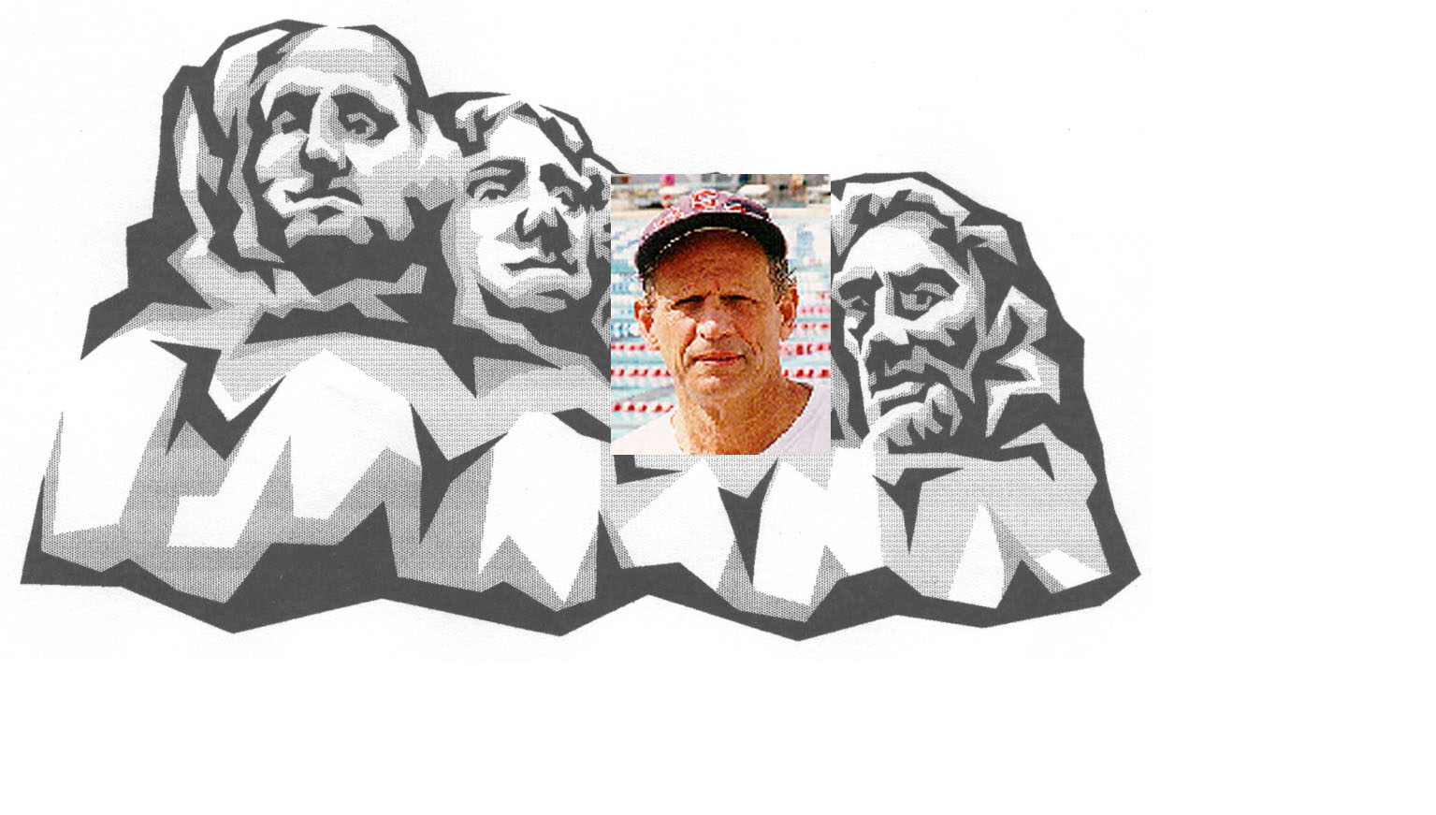

This will be my last report to you as Past President and I want to take this opportunity to thank all of you who had confidence in me to elect me president which allowed me to also serve as past president on the USMS Executive Committee this past 4 years. United States Masters Swimming has been a very important part of my life and I have enjoyed serving in this executive capacity for eight years for this wonderful organization. I have met and made many friends and hope to be a source of information for future USMS Executive Committees. At this convention you will elect a new administration that will take USMS to another level with new ideas and changes. I hope you give them the support you have given the current executive committee and me. My responsibilities on the USMS Executive Committee the past few years has been to interact and act as liaison to the USMS Championship and Coaches Committees. Both of these committees have been very active over the past year. I would suggest you read their convention report on their activities. Again thank you for the opportunity to serve you. I look forward to serving USMS in any capacity the new administration deems necessary.

LEGAL COUNSEL – Jeanne Crouse

During the past year, your Legal Counsel encountered a wide variety of assignments as I worked with and for the Executive Committee, including but not limited to drafting contracts with sponsors and answering questions from officers and members on topics ranging from insurance issues and sanctions to privacy matters and other intellectual property questions. We also have continued our fine tradition of keeping our Officers out of jail and other legal troubles. Even more notably, no litigation has prevailed against our organization; in fact, none has been reported currently as pending.

This year brought a new challenge regarding our corporate structure. As Nancy explains in her President’s Report, we have faced significant growing pains this past year as well as questions about our corporate form, some of which have resulted in legislative proposals that will be considered in due course under the procedures set forth in our rules.

We are a large and growing – indeed, vibrant – organization. It likely is time for us to evaluate the way that we conduct our business and consider methods to streamline and improve our processes. In order to give you – our delegates -- a foundation upon which to carefully consider these issues as our organization moves forward, I sought and obtained with the Executive Committee’s approval a formal opinion from an independent counsel analyzing the legal framework on which our organizational structure rests. Simply put, the USMS corporate structure is legal and proper.

As background, much of this discussion began late last year after our annual convention. At the mid-year meeting, the Executive Committee authorized me to engage Ross Wales to provide our organization with a legal opinion on our structure as well as guidance on various issues that had been raised. Meanwhile, by early spring, the rhetoric not only had escalated, but the discourse from certain members had deteriorated to nearly uncivil levels.

For those of you unfamiliar with Ross Wales, his USMS bonafides are considerable: Ross is a partner in the Ohio law firm of Taft, Stettinius & Hollister LLP in Cincinnati, where he specializes in the laws governing non-profit organizations and other corporate issues. He is well versed in the USMS corporate structure. He also has served as the President of then-US Swimming, the President of U.S. Aquatic Sports, and the Honorable Secretary of FINA.

Ross thoroughly reviewed all of our corporate documents, the 2001 Rule Book, and applicable law. His conclusions:

- There is nothing illegal or improper about the way our corporation is structured.

- We have filed all of the documents that Ohio law requires.

- Ohio law does not dictate that we follow a specific open meetings policy.

- Finally, given our growth, it would behoove us to obtain external audits periodically, although such audits are not required.

The bottom line here is that we are not required by law to make any changes to our structure, policies or practices. That being said, our organization continues to grow, and we might wish to review certain issues at this time and consider codifying policies that until now have been unwritten (such as our policy favoring open meetings) or consider changing previously longstanding practices. For example, we should strongly consider formally incorporating Roberts’ Rules (or some form thereof) into our Rule Book. Because we have grown, external audits probably should be performed periodically. And, notably, this might be an ideal time to begin to re-evaluate the various roles that our Board of Directors, House of Delegates, and Executive Committee play and to debate possible changes to or clearer definitions of those roles.

These are serious questions that could have a dramatic impact on the way we conduct our business and, therefore, are worthy of thoughtful deliberation. Let us now move forward through our legislative process to

LEGAL COUNSEL Continued

identify those changes or codifications we might wish to explore this legislative year and those issues that we might want to save for later action or to study in greater depth.

In the event that we should ultimately decide as an organization to adopt any or all of the legislative proposals we soon shall consider, so be it. But our delegates should not feel rushed into precipitous or premature decisions for fear that Ohio law requires change, because it does not. Our organization is in compliance with Ohio law.

Ross’ formal letter is included in its entirety (following this report) for your review. If you should have any questions about his letter or any other legal issue, as always, please feel free to contact me.

